SOCIAL MEDIA PROJECT

ObjectiveQuestions

1. Are there any tables with duplicate or missing null values? If so, how would you handle them?
Ans. I generated a query Using the GROUP BY clause to group all rows by the target column(s) – i.e. the column(s) you want to check for duplicate and null values on.
And this proves we don’t have any duplicate values or any Null values.
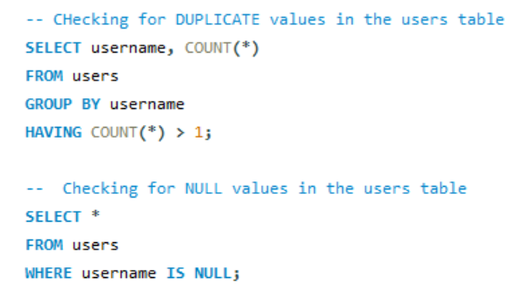

2. What is the distribution of user activity levels (e.g., number of posts, likes, comments) across the user base?
Ans.
For this problem I have written a query in which I calculated the total count of likes, comment, and number of posts made by the users from various tables such as photos , likes and comment tables.

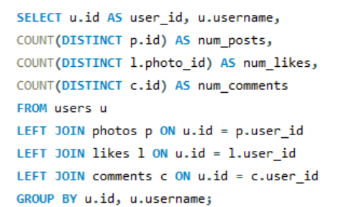
The distribution of user activity according to the likes, comments and number of posts as following

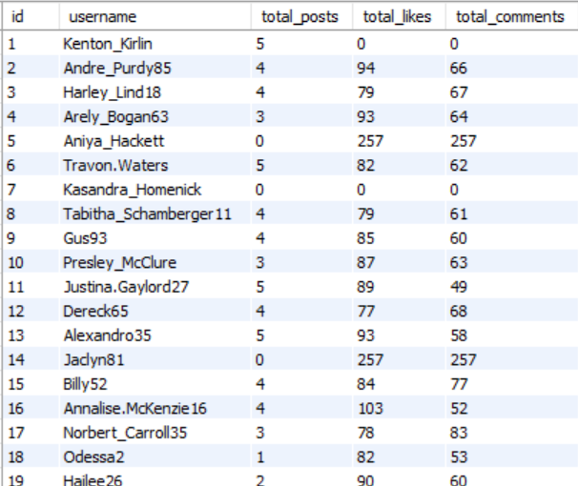
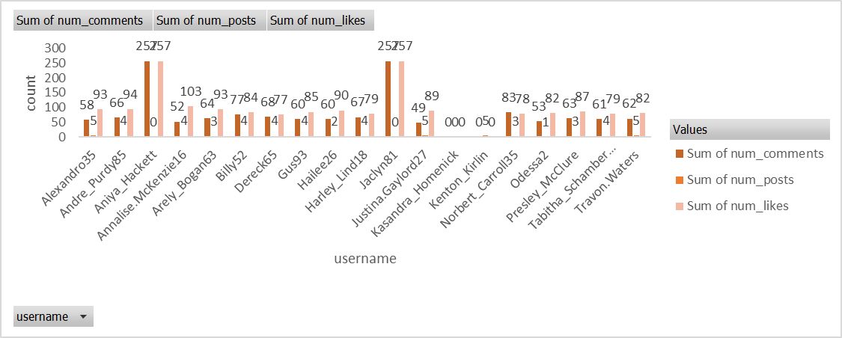

3. Calculate the average number of tags per post (photo_tags and photos tables).
Ans. I found the average number of tags per posts and the ans came 1.9494.
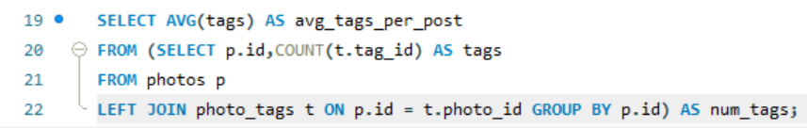

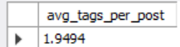

4. Identify the top users with the highest engagement rates (likes, comments) on their posts and rank them.
Ans.
To identify the top users with highest engagement rates I created a Query in this query I have created temporary tables ‘l’ and ‘c’ using subqueries in which I calculated total likes by a user_id and total comments by a user_id then joined these two tables with the main query to find the user_id, username and there subsequent total likes and total comments.
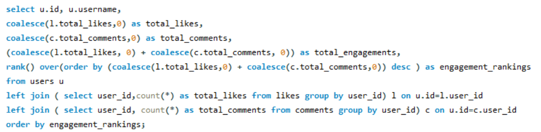
Giving us the following output.
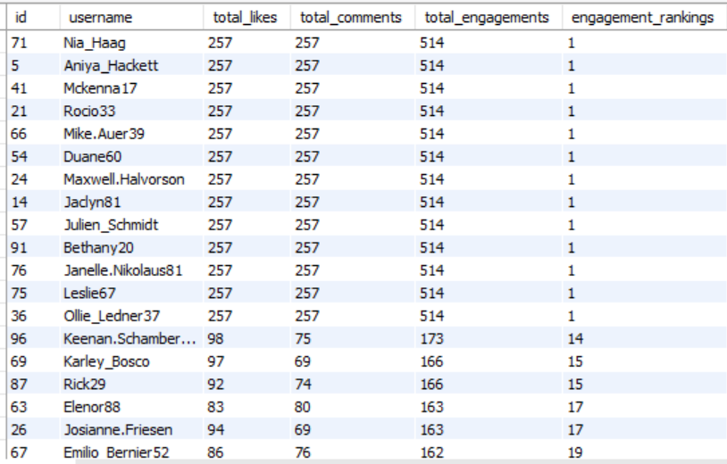

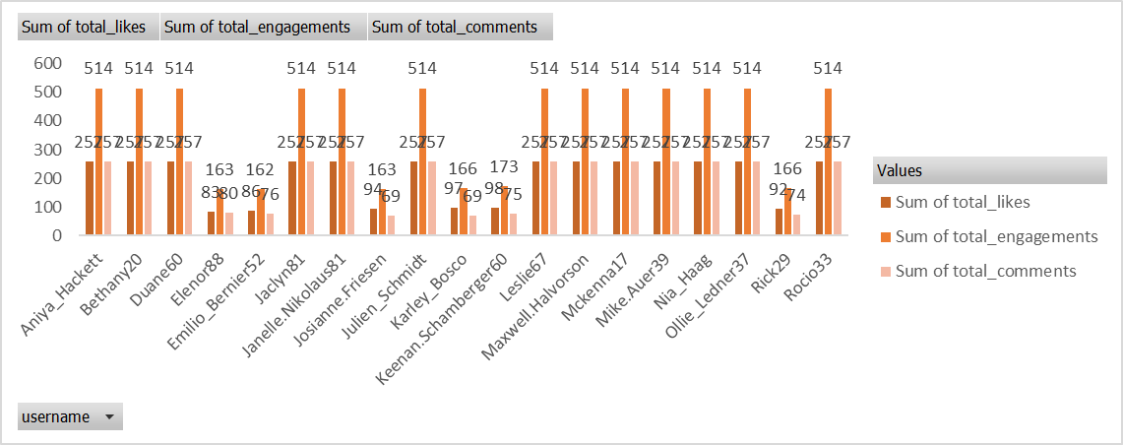

5. Which users have the highest number of followers and followings?
Ans.
In this query I used ctes(Common Table Expression) concept to create tables for finding followee_id and their followers_count and follower_id and their following_count respectively. Then I joined both the ctes with the main query to find user_id, username, followers count, following count. And generated the following output.
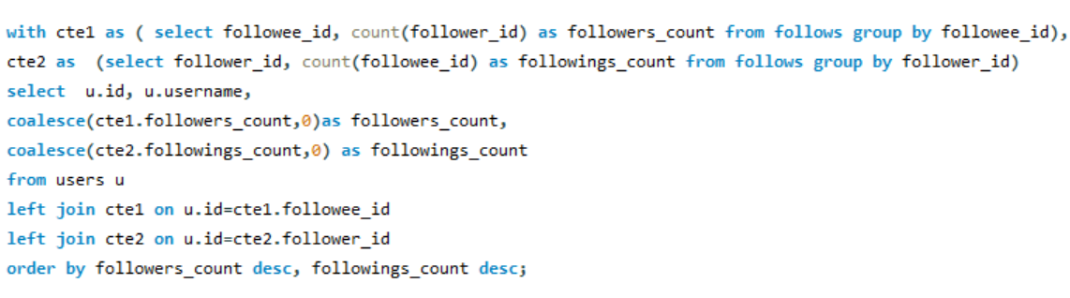
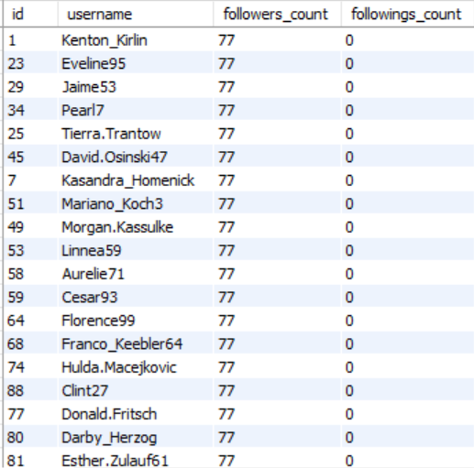

6. Calculate the average engagement rate (likes, comments) per post for each user.
Ans.
In this question I found the total number of posts, total number of likes and total number of comments per user using subqueries and joined them in the main query using left joins then in the main query I used the calculated number of likes, comments and posts to find the average engagement rate for each user.
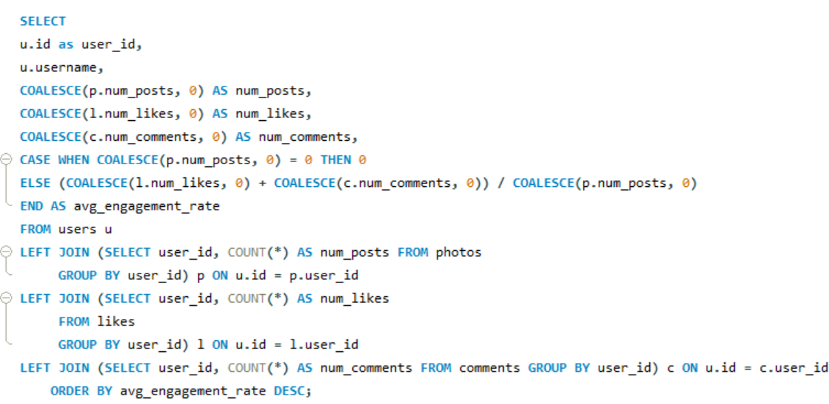
The following is the output for average engagement rate for every user.
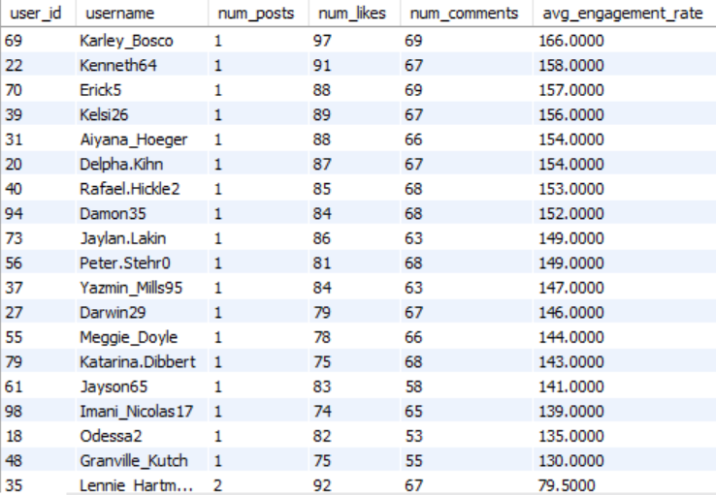
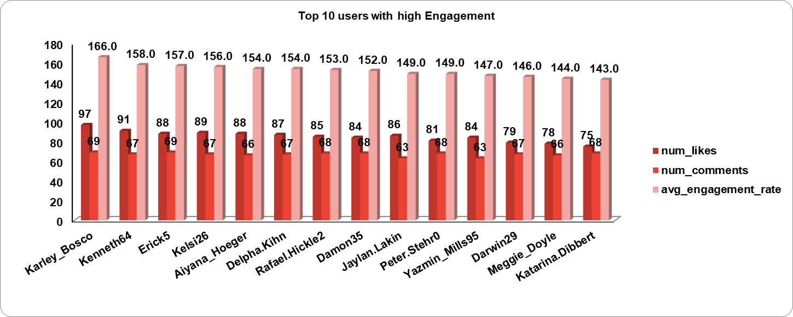

7. Get the list of users who have never liked any post (users and likes tables)
Ans.
I found the id and usernames of those users who haven’t liked any posts by writing a simple query in which I joined the users table with the likes table. 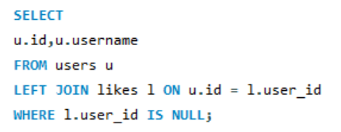
This query gave us the desired output of the list of those users who have never liked any post.
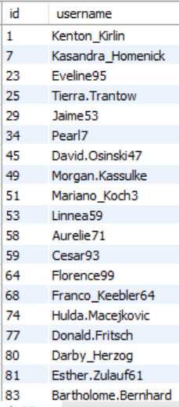

8. How can you leverage user-generated content (posts, hashtags, photo tags) to create more personalised and engaging ad campaigns?
Ans.
We can leverage user-generated contents to create personalized and engaging ad campaigns, the following points are ways how we can utilize them for increasing user engagement.

- Using data and observation of the user activity such as posts, hashtags they use or like the most we can create personalized and engaging ad campaigns.

- By analyzing user-generated content, brands can identify popular themes, hashtags, and types of posts that resonate with their audience.

- The insights allow targeted ad campaigns that align with user interests, enhancing engagement. Additionally, utilizing user-generated content in ads can foster community and authenticity, making campaigns more relatable.

- User friendly and customized notifications and emails can be used to engage the users and keep the user posted about the content they like the most, also updating them about new hot topics.

9. Are there any correlations between user activity levels and specific content types (e.g., photos, videos, reels)? How can this information guide content creation and curation strategies?
Ans.

Approach for finding correlation :-

- Correlation analysis can be conducted using statistical methods to examine relationships between user activity levels and content types.

- If a strong correlation is found between engagement and specific content types, brands can focus on producing more of that content to maximize user interaction and satisfaction.

On thorough analysis of the given dataset and reviewing the user’s behaviour on the basis of type of content, hashtags on various photos, videos and reels I came to a conclusion that
Yes, there are correlations between user activity levels and specific content type because particular genres are getting more engagement than other contents, also user activity levels are increasing and if engagement is increasing then the specific type of content is also increasing.
This information can guide us for content creation and curation strategies by many ways such as:
- Trendy and hot topics must be regularly added in the hashtag list to introduce new topics and content creation.

- The user should be given suggestions and recommendations for contents according to the user's interests and the content they follow more and watch more often.

- Use of hashtags related to trending and hot topics for better engagement on posts.

10. Calculate the total number of likes, comments, and photo tags for each user.
Ans.
In this query I utilized subqueries and joins for finding total likes, total comments, total photo tags then joined them to the main query to find the id, username and their respective total likes, total comments, total photo tags.
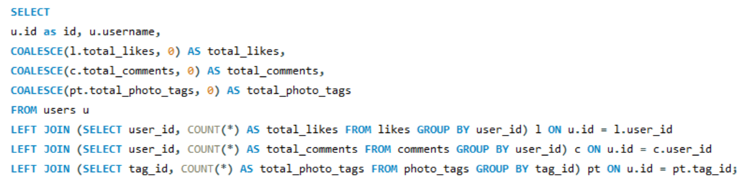

Thus giving me the following output.
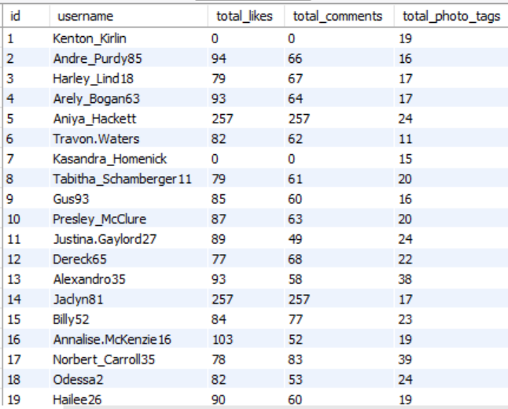
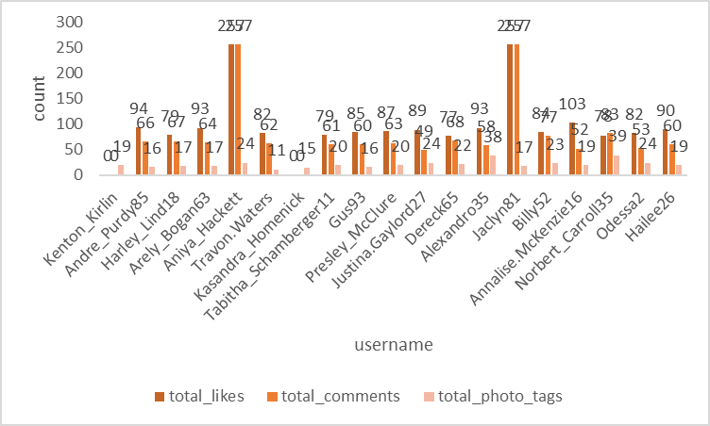

11. Rank users based on their total engagement (likes, comments, shares) over a month.
Ans.
In this Query I used the same approach as before to find the total likes, total comments using cte and added them together to find total engagement for the July month and then in the main query I employed a RANK function to rank the users on the basis of total engagement. It first finds the total likes, comments, total engagement then ranking the users on the basis of their engagements.
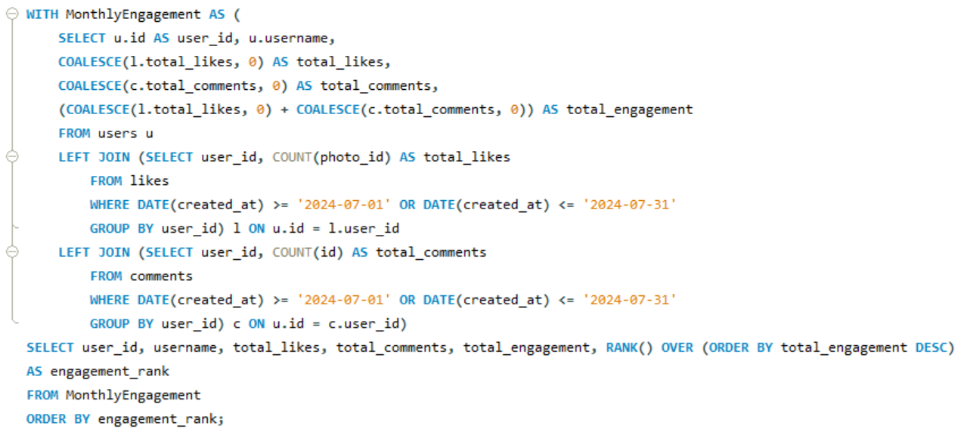
This gave me the desired output in which I got user_id, username, their total likes, total comments, total engagements and their ranking based on their engagement.
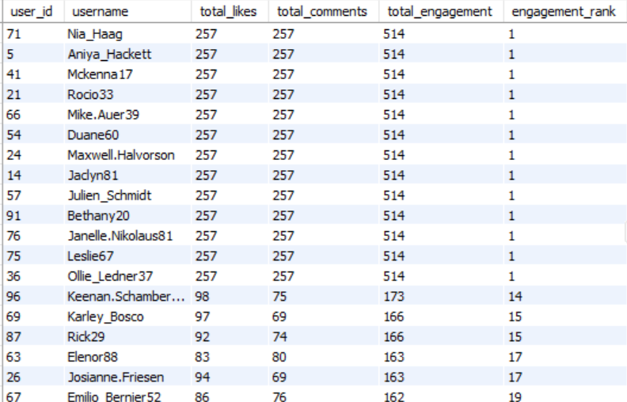
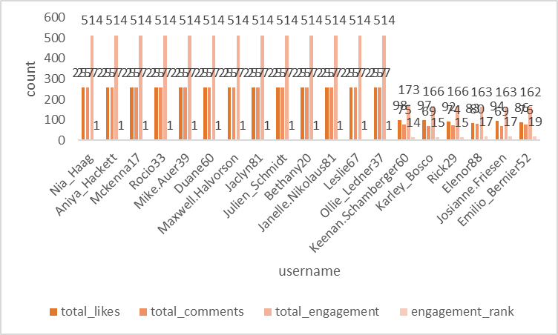

12. Retrieve the hashtags that have been used in posts with the highest average number of likes. Use a CTE to calculate the average likes for each hashtag first.
Ans.
To retrieve the hashtags that have been used in posts with the highest average number of likes. Here I used two ctes to find total count of likes and the total posts then I calculated the average number of likes per post in the second cte. Then in the main query I selected the top 5 Tags which have the highest number of likes.
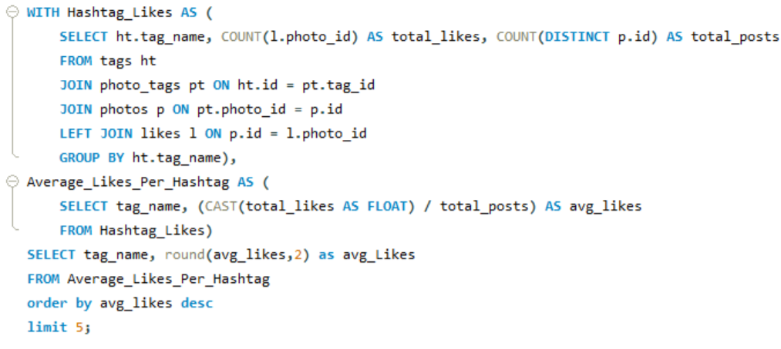

This query gave the following desired output.
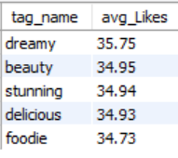
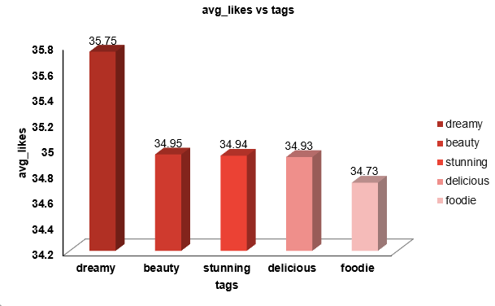
13. Retrieve the users who have started following someone after being followed by that person
Ans.
In this question in order to retrieve the users who have started following someone after being followed by that person I employed a Query where I used the created_at column to compare the followee_id and follower_id whichever was created before. But didn’t find any such record proving there is no such kind of users.
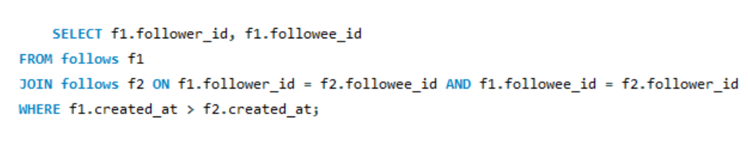
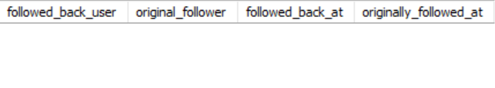

Subjective Questions

1. Based on user engagement and activity levels, which users would you consider the most loyal or valuable? How would you reward or incentivize these users?
Ans
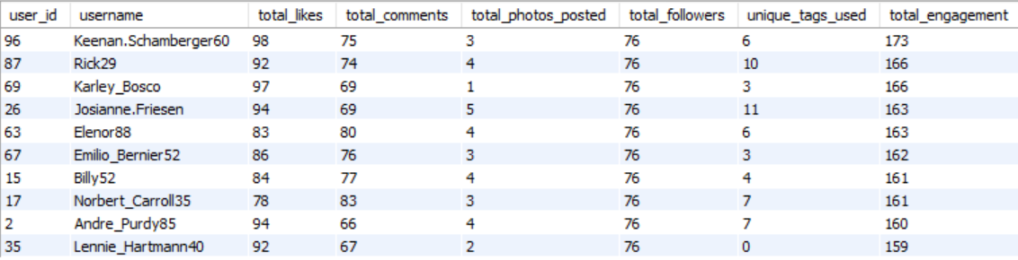
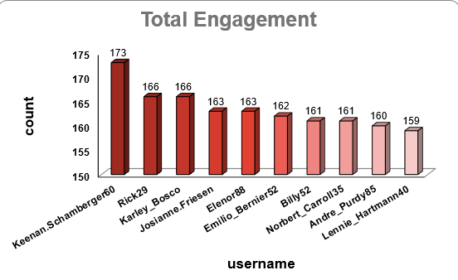
Loyal and Valuable users are those who contribute the most to the website. An user may contribute by performing regular activities and engaging the most by doing activities like posting, liking, commenting and engaging in a website's activities. To find the most valuable and loyal users we have to find the users with the highest and regular activities of users.

To find those users I wrote a query using cte and joins where first I found the users and their total posts, users and their total likes, users and their total comments then finally finding their
Total engagements by adding their count of likes and count of comments as a whole and then ordering the final output on the basis of their total engagements in descending order.
This gave us the Users who can be said are the 10 most loyal and valuable users.

2. For inactive users, what strategies would you recommend to re-engage them and encourage them to start posting or engaging again?
Ans.
For inactive users I’ve generated an approach through which we can make them more active and engaged again.

- Personalized Communication: Send them personalized emails or notifications reminding them of their previous activity or showcasing what they’ve missed while they were gone.

- Games: Introduce challenges or rewards for returning users, like "Come back and get a special badge" or "Join our 7-day posting challenge."

- Content Inspiration: Provide content suggestions based on past activity or trends they might like, reducing the barrier to re-engagement.

- Incentives: Offer rewards like discounts, special features, or access to exclusive content for returning to the platform.

3. Which hashtags or content topics have the highest engagement rates? How can this information guide content strategy and ad campaigns?
Ans.
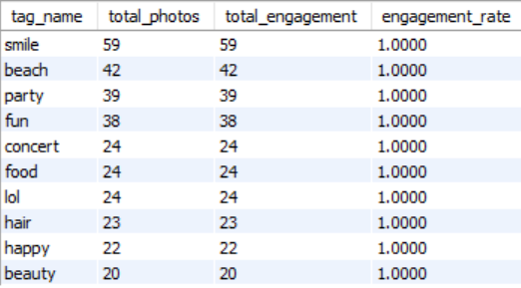
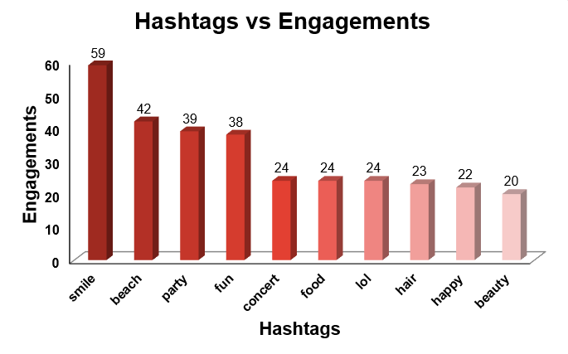
Hashtags or topics that have the highest engagement rates are those tags which have been used the most in posts and those which have the highest engagement such as smile, beach and party. We can find the engagement rate from total uses and total engagement that shows how many times a tag is used while posting an engagement.
To find those hashtags I constructed a Query to find the total likes, total comments and total engagements of the users. Then with the help of this cte I found the hashtags that have been used in those posts.
We can use this information to promote those hashtags and motivate the users to use those tags. Below are some key points that we can follow to strategize and ad campaigns.
- Identify High-Engagement Hashtags: Analyse the data to find hashtags associated with posts that have the highest likes, comments, and shares.
- Content Strategy: Encourage users to use these hashtags by featuring them in challenges or content prompts. Create campaigns centred around trending topics or popular hashtags.
- Ad Campaigns: Use these hashtags to target ads, ensuring they align with popular topics, thereby increasing relevance and engagement. Create ads that resonate with the interests and engagement patterns of your audience.

4. Are there any patterns or trends in user engagement based on demographics (age, location, gender) or posting times? How can these insights inform targeted marketing campaigns?
Ans.
For this I constructed a Query to check the Total photos posted, total likes received on that photo, and total comments on those photos at particular time and days of week.
Which gave us the following output.
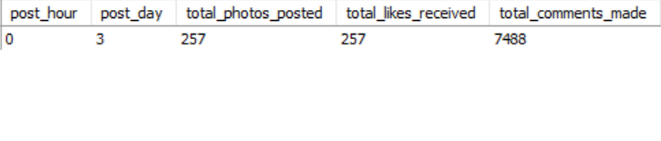
Here we can see that the photos posted on the 3rd day of the week, that is Wednesday, have the most responses and engagements, So yes there is a pattern between user engagement and posting times.
- For reaching to this result I followed the following Approach:
  - Analyse Time & Days Data: Look for correlations between user demographics and engagement metrics. Identify peak engagement times across different demographic groups.
  - Targeted Campaigns: Use insights to create targeted ads and content. For example, if younger users are more active in the evening, schedule posts and ads to appear during those times.
  - Content Personalization: Create content that resonates with specific demographics based on their engagement patterns. Tailor messaging and imagery to match the preferences of different groups.

5. Based on follower counts and engagement rates, which users would be ideal candidates for influencer marketing campaigns? How would you approach and collaborate with these influencers?
Ans.
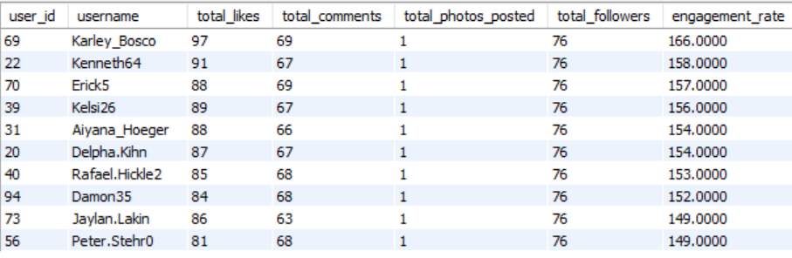
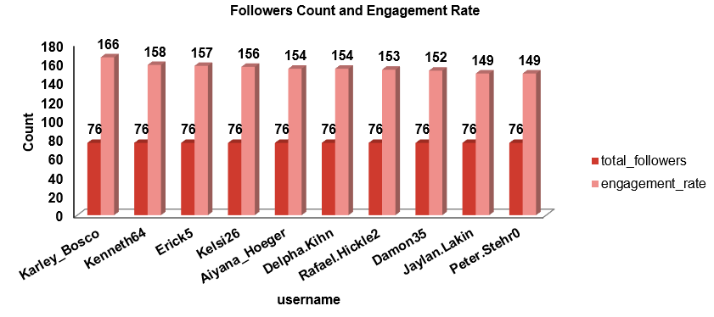
To find the users who would be ideal candidates for marketing campaigns first we have to find the users with most engagements. To find those users with the most engagement, I constructed a Query to find the top 10 users who have the highest engagement rate and most number of followers.
In this Query I used ctes to find the users with highest number of followers and then among those users who have highest engagement rates. By calculating total likes, total comments on their posts and limited the result to only top 10 users. With this I got top 10 users who are influential among all.

The Approach for this problem statement:
- Identify Potential Influencers: Look for users with high follower counts and strong engagement rates. Prioritize those whose content aligns with your brand values and target audience.
- Collaboration Strategy: Reach out with a clear value proposition—what they gain from partnering with you. Offer opportunities like product collaborations, sponsored content, or exclusive access to events or features.
- Relationship Building: Foster long-term relationships with influencers rather than one-off campaigns. Consider offering affiliate programs or ambassador roles.

6. Based on user behaviour and engagement data, how would you segment the user base for targeted marketing campaigns or personalized recommendations?
Ans.
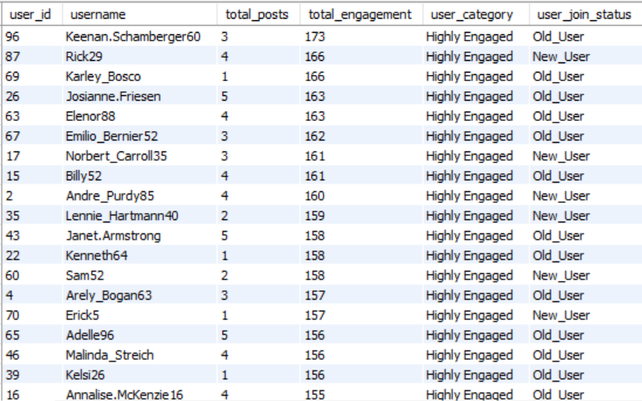
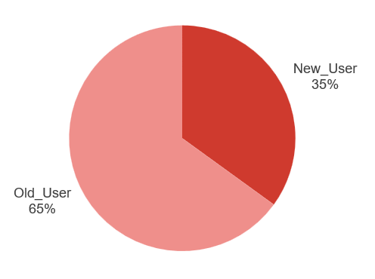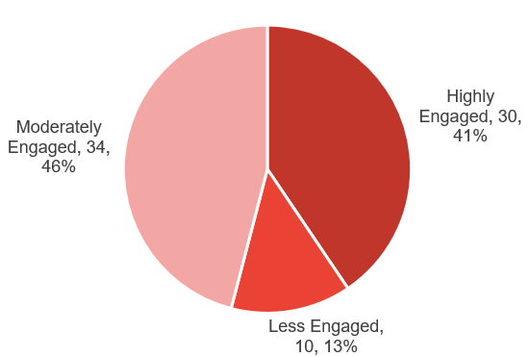
Based on user behaviour and engagement data I classified the users in Three main segments that are ‘Highly Engaged’ , ‘Moderately Engaged’ and ‘Less Engaged’. Based on their Engagements. If the user has a total of engagements more than 150 then they are considered as ‘Highly Engaged’ and if the users have total engagement between 100 and 150 then they are classified as ‘Moderately Engaged’ at last if the users have engagement rate less than 100 the are considered ‘Less Engaged’.
I furthermore classified the user in two more segments on the basis of time period of their account, if the account has been created in or after 2017 then they are called ‘New User’ and those users who created their account before 2017 are called ‘Old Users’. These classifications will help us in targeted marketing and personalized recommendations.
For this Query I used the Cte and Joins concept that I used before for finding the total likes and total comments and total engagements of the users. Then using the CASE function I classified these users on the basis of total engagements and on the basis of account creation year.
This Query gave us the following result and the names of users with the segment they fall in.

The approach that I followed in this problem statement are:
- Segmentation Criteria: Segment users based on engagement levels, content preferences and time period on website (e.g., frequent likers, commenters, or content creators).

- Targeted Marketing: Create different marketing strategies for each segment. For example, offer personalized recommendations for frequent shoppers or exclusive content for top engagers.

- Personalization: Use segmentation to personalize user experiences on the platform, such as personalized feeds, content suggestions, or targeted notifications.

7. If data on ad campaigns (impressions, clicks, conversions) is available, how would you measure their effectiveness and optimize future campaigns?
Ans.
To measure the effectiveness of ad campaigns, it's important to analyze various metrics that provide insights into how well the campaign is performing in reaching and engaging the target audience. The aim is to not only evaluate the campaign's performance but also to use this information to optimize future campaigns for better results.
Measuring Effectiveness:
- Impressions: High impressions indicate good visibility. However, impressions alone don't tell the full story of effectiveness. They need to be analyzed in conjunction with other metrics like clicks and conversions.
- Clicks: A higher Click Rate suggests that the ad content, creative, and targeting are compelling and relevant to the audience. Low Click Rate might indicate that the ad is not engaging or that it is being shown to the wrong audience.
- Conversion Rate: A high conversion rate indicates that not only are users interested enough to click the ad, but they are also motivated to take further action. A low conversion rate could point to issues with the landing page, the offer, or the overall user experience.
- Engagement Metrics: High engagement indicates that the ad content resonates with the audience, which can increase brand awareness and loyalty, even if it doesn't immediately lead to conversions.
Optimizing Future Campaigns:
- Testing: Test different versions of your ad (e.g., headlines, images, calls to action) to see which performs better. Use the results to refine future ads. If one version of an ad has a higher Click Rates or conversion rate, focus more resources on that approach.
- Refining Targeting: Analyze which audience segments (age, gender, location, interests) are responding best to your ads. Adjust targeting to focus on high-performing segments. If data shows that a particular demographic converts at a higher rate, allocate more of your ad budget towards reaching this group.
- Optimizing Ad Platforms:Evaluate which platforms or ad placements (e.g., social media, search engines, websites) are generating the best results. If ads perform better on a particular platform or time of day, shift your ad spend to maximize visibility during those peak times or locations.
- Utilizing Retargeting: Use retargeting to show ads to users who have previously interacted with your brand but didn’t convert. If data shows a significant drop-off after the initial interaction, retarget those users with personalized ads to encourage them to complete the conversion.
- Continuous Monitoring and Iteration: Regularly monitor campaign performance and be ready to make adjustments as needed. If you notice a decline in performance metrics, don’t hesitate to tweak your ads, targeting, or budget in real-time.
By systematically measuring the effectiveness of our ad campaigns using these metrics and strategies, we can make data-driven decisions to optimize future campaigns, ensuring higher engagement, conversions, and overall return on investment.

8. How can you use user activity data to identify potential brand ambassadors or advocates who could help promote Instagram's initiatives or events?
Ans.
We have the categories Highly Engaged, Moderately Engaged and Less Engaged so now we will see which of these users are highly engaged, have more followers and regularly posting, we will prioritize them as potential brand ambassadors or advocates. Here's how we can leverage user activity data for this purpose:

Identify Highly Engaged Users:Track users with a consistently high engagement rate, which includes frequent likes, comments, shares, and story interactions. These users are actively involved with the content and show genuine interest in the brand.Identify users who frequently share the brand’s content or mention the brand in their posts and stories. Sharing indicates that they are not only engaging but also helping to amplify the brand’s message.

Analyze Influence and Reach: Look for users with a significant number of followers, as they have the potential to reach a larger audience. While follower count alone isn't sufficient, it’s a good starting point. Identify whether the user is already an influencer within a relevant niche. Influencers who align with the brand’s values can effectively promote initiatives or events.

Monitor Content Quality and Alignment with Brand Values:Review the type of content the user regularly posts. Are they creating content that aligns with the brand’s image and values? For instance, if Instagram is promoting a wellness event, users who frequently post about health, fitness, or mindfulness could be ideal ambassadors.Look for users who demonstrate creativity and originality in their posts. High-quality, visually appealing content can enhance the brand’s image when shared.

Track Loyalty and Long-Term Engagement: Identify users who have been consistently engaging with the brand over an extended period. Long-term engagement indicates loyalty and a deeper connection to the brand. Look for users who have already advocated for the brand in the past without any incentive. Their genuine support makes them strong candidates for formal ambassador roles.

Evaluate Potential for Authentic Advocacy: Assess whether the user’s interactions with the brand appear genuine or if they are merely engaging for incentives (e.g., giveaways). Authenticity is key to effective brand ambassadorship. Analyze any user-generated content where the individual shares personal experiences with the brand’s products or services. Testimonials can indicate a strong connection to the brand, making them more credible as advocates.

Reach Out and Engage Potential Ambassadors: Engage with these users directly through comments, likes, or direct messages. This can help establish a relationship and assess their willingness to collaborate. Offer them opportunities to participate in exclusive events, beta tests, or product launches. This not only strengthens the relationship but also provides a platform for them to naturally promote the brand.

9. How would you approach this problem, if the objective and subjective questions weren't given?
Ans
Well certainly the Objective and Subjective questions were very helpful as they provided the outline and better understanding of the problems and how to reach the solutions. But if the case was that the Objective and Subjective questions were not given then I would have followed a certain approach with certain steps to analyse and come up with insights from the given data.

The Approach and the steps in it would be as follows:
- Problem Identification: I would start by understanding the goals and desired output of the analysis, whether we are optimizing user engagement, increasing retention or identifying potential influencers. After analyzing all this I would set up my plan and course of action on how I am going to manipulate the data.
- Data Exploration: Conduct an reading analysis to understand the data structure, distribution, and any initial trends or faulty data and whether any direct conclusion can be made with the raw data or not.
- Data Cleaning and validation: I would start working on the data and my first step would be to check for null values and duplicates in all the tables and if found then rectify them. So that data can be ready to work on.
- Trend Formation: Develop hypotheses based on observed trends or known business goals. For example, "Users who engage more frequently are more likely to retain." Then check for their followers' activity and various other things from which we can come to conclusion whether to work with them or not.
- Data-Driven Solutions: Then finally I would use SQL operations on the data to check whether my overview analysis stands correct or not and if not then what are the trends and how the current trends are different and varying from the desired results..
- Insights of Current Scenario: At last I would take all the outputs from the SQL operations and create a Report of current scenario and how much we need to work in which aspects. The analysis will give us the aspects in which we are lacking behind, So that the management can take proper actions to rectify them.

10. Assuming there's a "User_Interactions" table tracking user engagements, how can you update the "Engagement_Type" column to change all instances of "Like" to "Heart" to align with Instagram's terminology?
Ans
For this problem first I created a new Table User_Interactions with the following Query.
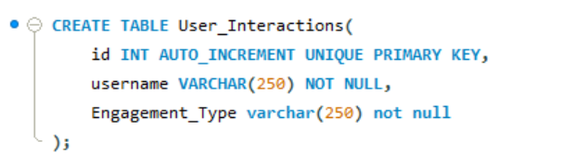

After creating the User_Interaction table then I entered values in the table taking from the original table data.
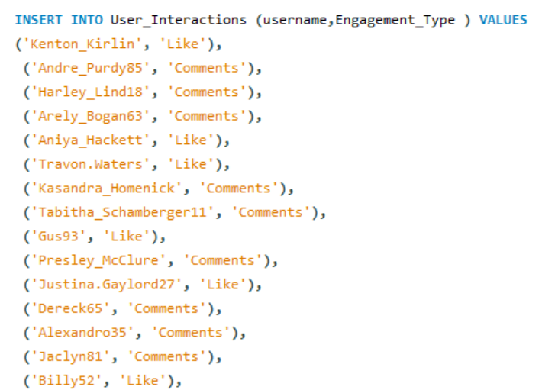

Finally for updating the values in the table User_Interaction which was the original problem statement I constructed the following SQL Query

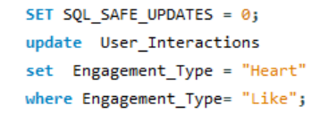
From the above query I got the desired output updating the "Engagement_Type" column to change all instances of "Like" to "Heart" to align with Instagram's terminology.

